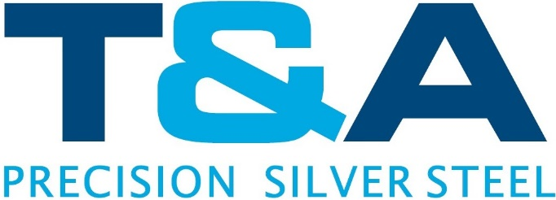

LONG TERMS DECLARATION FOR GOODS HAVING PREFERENTIAL ORIGIN STATUS

T & A Precision Grinding Co Ltd (Andrew Oates – Director) declare that the goods described below:

BRIGHT DRAW SILVER STEEL BARS - TARIFF CODE 722850-69

Which are regularly supplied to:

Name:

Originate in: The UK
And satisfy the rules of origin governing preferential trade with EFTA:
(Iceland, Norway, Liechtenstein, Switzerland)

CEES:

(Bulgaria and Romania), Faroe Islands, Israel, Ceuta and Melilla, Mashraq Group (Egypt, Jordan, Lebanon, Syria), Maghreb
Group (Algeria, Morocco, Tunisia), ACP, OCT, West Bank/Gaza, South Africa, Croatia, Macedonia, Bosnia-Herzegovina, Albania, Serbia, Mexico, Turkey and GSB beneficiary countries.

This declaration is valid for all further supplies of these products dispatched

From: March 2022

Andrew Oates
Director

